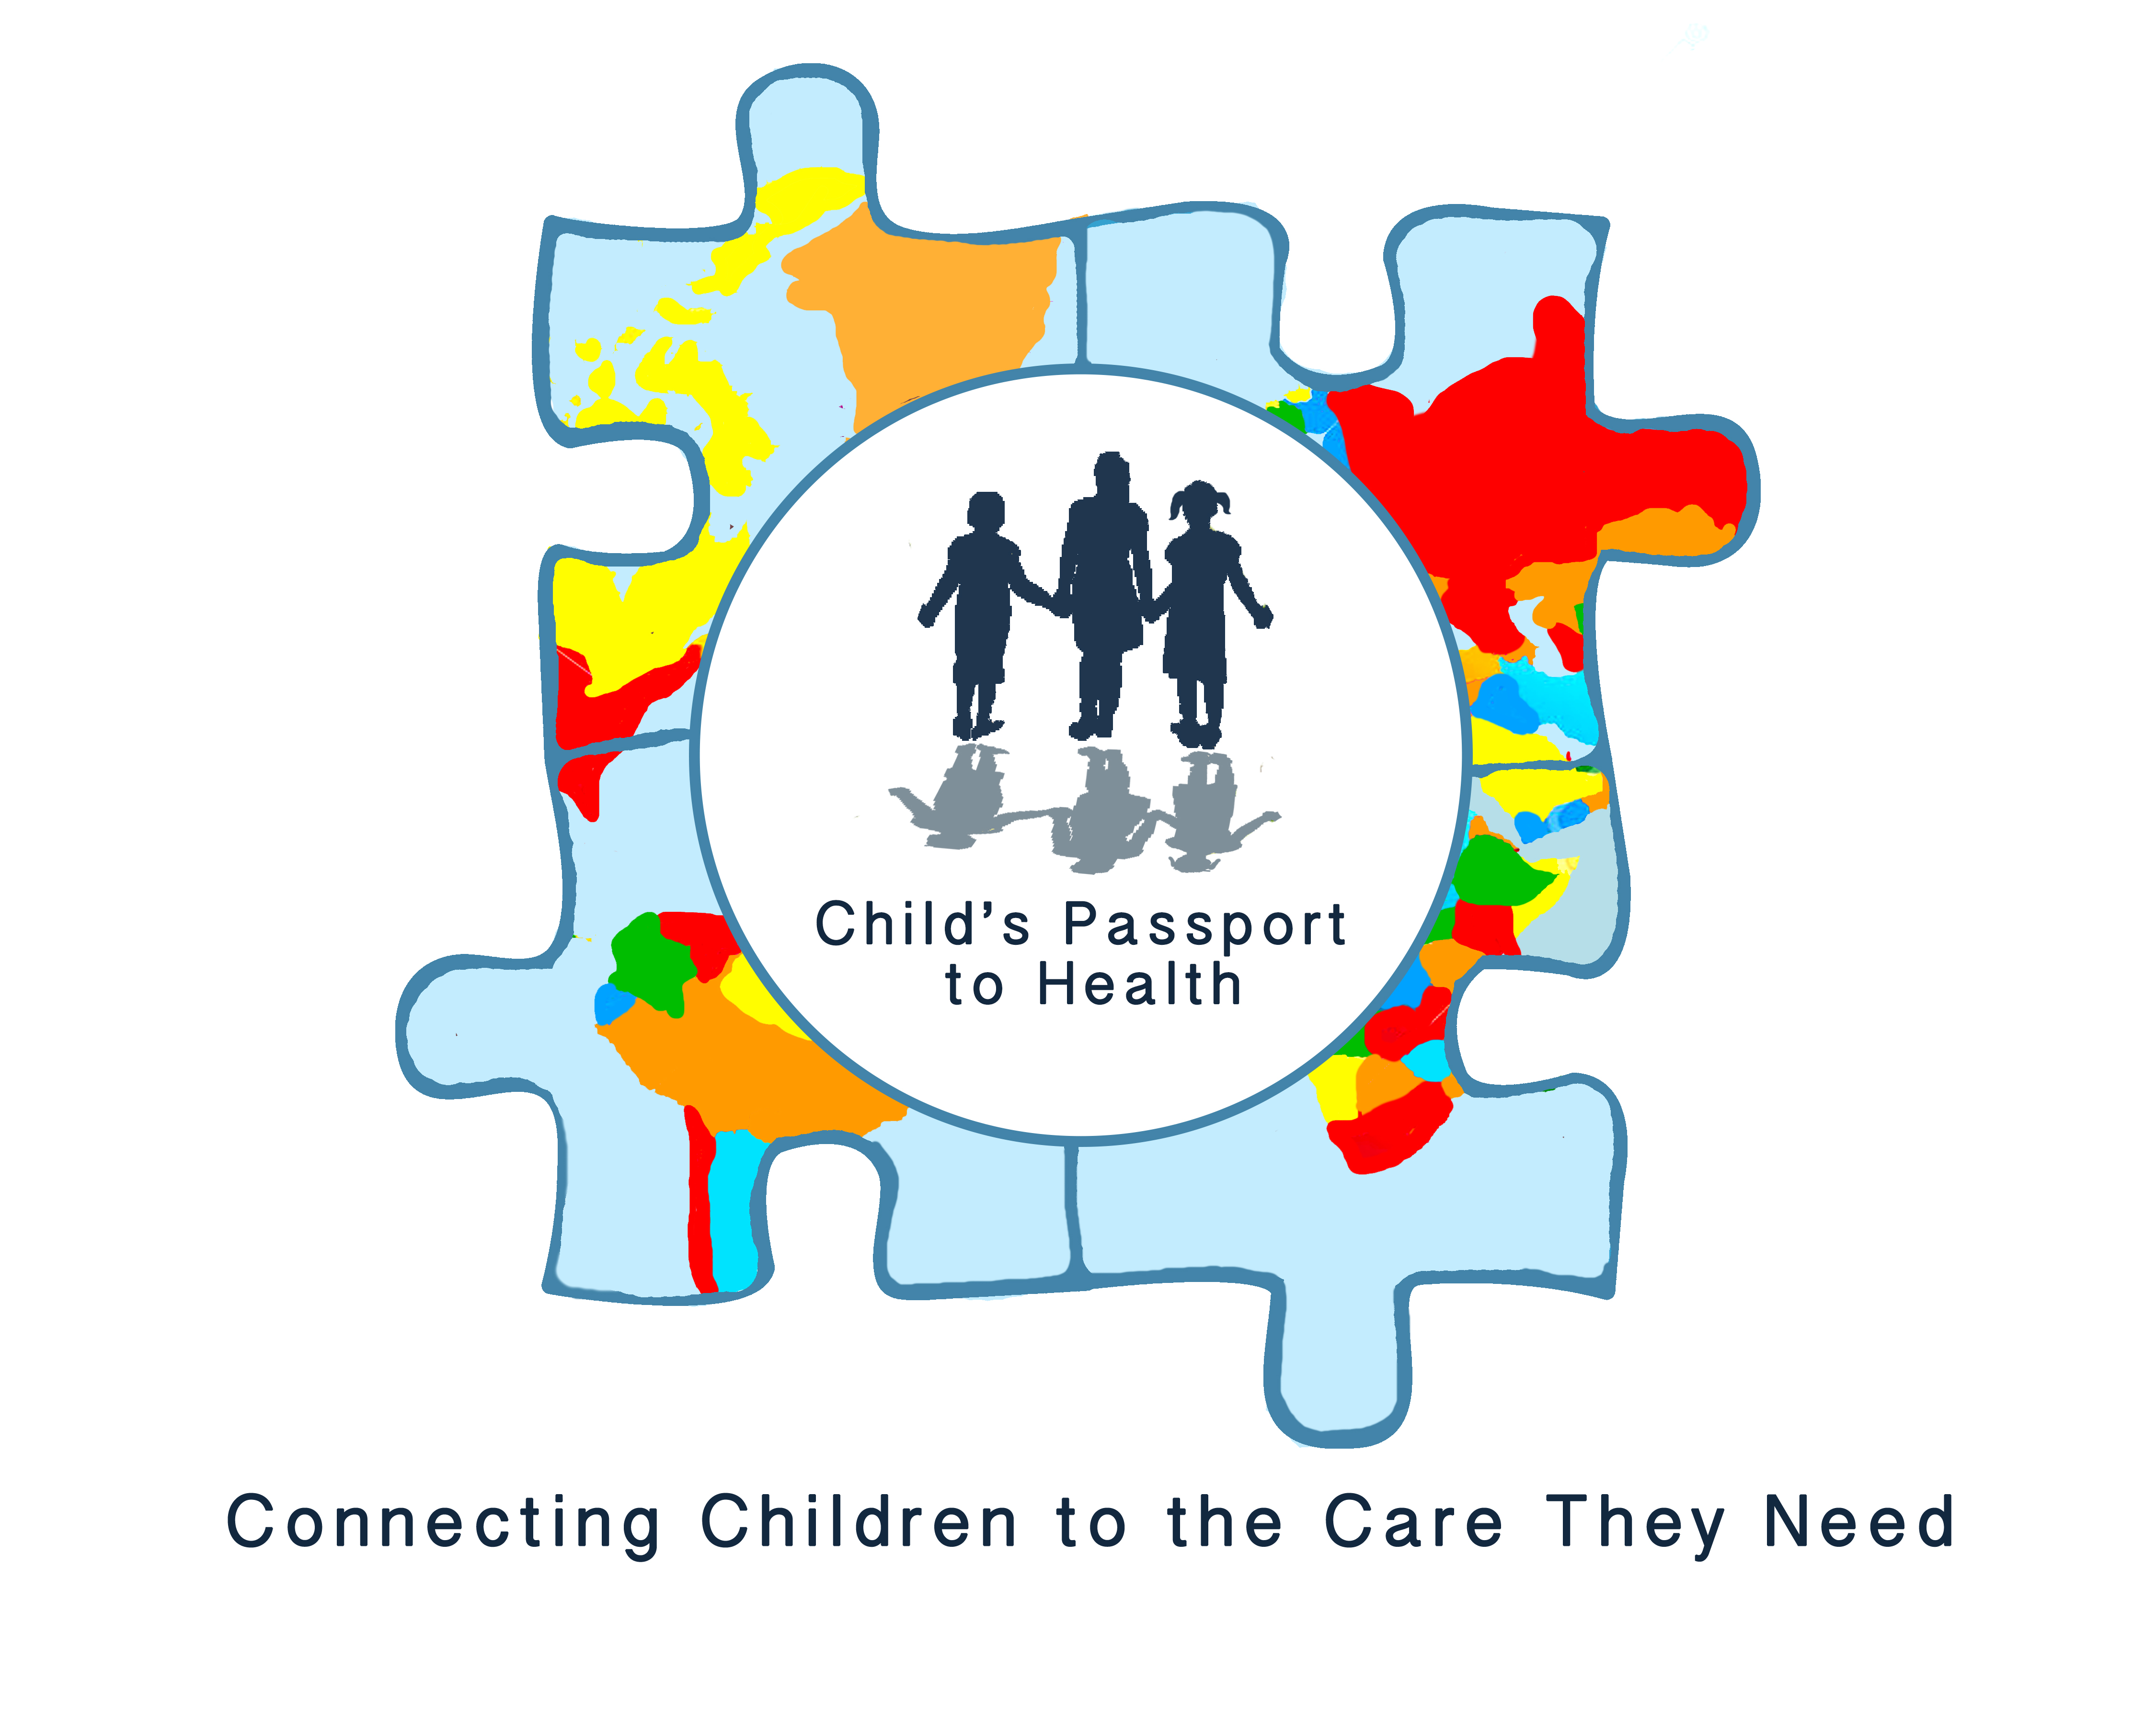
Dear Colleagues and fellow volunteers,

On behalf of the Board of Directors, thank you for volunteering to be part of Child’s Passport to Health Surgical/Medical Teams. We appreciate your participation and willingness to serve with our organization. As a Volunteer you are invaluable to helping us reach our mission to improve children’s lives through donated health care and services.

Child’s Passport to Health is a not for profit organization founded in 2014 with the mission to improve the ongoing quality of life for children through surgical/medical intervention and education, in partnership with their community, biological and host families.

Enclosed you will find the documents needed for your application for the Surgical/Medical Team. Please return to Team Leader within one week. Thank you once again for your support, and we look forward to working with you.

Sincerely,

Mary
Mary Dennison, Co-founder/President
Child’s Passport to Health

www.childs-passport.org

2019 LEADERSHIP

BOARD OF DIRECTORS

Mary Dennison, Co-founder and President

Terry Martaus, Medical teams

Jan von Lehe,

CP2H SURGICAL/MEDICAL TEAMS
A. Trip Registration Form

I am interested in being considered as a medical team volunteer for an upcoming CP2H Surgical/Medical Team.
I am a returning CP2H Medical Team volunteer | I am a new CP2H Medical Team volunteer

Name: ________________________ Date: ___________________
COUNTRY: __________ _______ TEAM LEADER: _______________
DATES OF TRIP: ____________________ TEAM ADMINISTRATOR: __________________

FORMS | Attached
- Trip Registration Form
- Application and Medical History
- Code of Ethics & Professional Conduct
- Risks and Travel Information
- Assumption of Risk, Release and Waiver of Liability
- Evacuation Insurance
- Background Check Consent

Supporting Documents | Attached
- Copy of Driver’s License
- Copy of Passport (must be valid 6 months post trip)
- Copy of current Medical License
- Copy of Medical Diploma or Certificate
- Copy of Curriculum Vitae (CV)

PLEASE NOTE: If participant is a minor, all certifications must be completed by parent/guardian unless otherwise noted

Send YOUR COMPLETED FORMS TO:

- email to YOUR Team administrator or team leader, as requested
- or – mail to Child’s Passport to health @ PO Box 446 bothell WA 98041

CP2H SURGICAL/MEDICAL TEAMS
B. Application and Medical History

About You:
NAME (AS IT APPEARS ON YOUR PASSPORT)

ROLE ON MEDICAL TEAM | CERTIFICATIONS | NUMBER OF PRIOR OVERSEAS MEDICAL TEAMS
ADDRESS (HOME) CITY STATE ZIP CODE |  | CELL NO.
EMAIL ADDRESS (HOME) |  | ALT PHONE NO.

CURRENT WORK HISTORY:
EMPLOYER |  | LENGTH OF TIME
ADDRESS (WORK) CITY STATE ZIP CODE |  | PHONE NO. (WORK)
POSITION TITLE

PERSONAL MEDICAL HISTORY:
LIST KNOWN ALLERGIES: (MEDICINES, ETC.)

LIST SIGNIFICANT MEDICAL PROBLEMS

MEDICATIONS TAKEN REGULARLY
DRUG | DOSE |  | FREQUENCY
PRIMARY PHYSICIAN NAME |  | PHONE NO. (WORK) |  | INSURANCE CO. AND ID NUMBER
PHYSICAN ADDRESS CITY STATE ZIP CODE

EMERGENCY CONTACT:
NAME | spouse | PHONE NUMBER
ADDRESS CITY STATE ZIP CODE

CERTIFICATION:
By checking this box I certify that I have completed all the required forms for child’s passport to health medical trip and that I will abide by the terms and conditions therein.
Name:__________________________ Date: ___________

CP2H SURGICAL/MEDICAL TEAMS
C. CODE OF ETHICS & PROFESSIONAL CONDUCT

CODE OF ETHICS & PROFESSIONAL CONDUCT
Our Operating Principles: Child’s Passport to Health provides Surgical/Medical care and treatment without regard to sex, handicapping conditions, religious belief, national origin, political views, or cultural differences.

Due to the international scope of Child’s Passport to Health, it is imperative to establish a code of ethics that is conducive to portraying high standards of professionalism, and that provides an atmosphere for building international goodwill and positive working relationships among team members.

Each volunteer becomes an ambassador not only for Child’s Passport to Health, but also for the United States of America. It is expected that all volunteers conduct themselves in a manner consistent with the mission of Child’s Passport to Health and sensitive to the cultural values of the host country. Participants are expected to demonstrate responsible behavior that builds positive relationships, affirms the value of the individual and culture, contributes to respect for self and others, and promotes a healthy lifestyle. This includes but not be limited to: (1) drugs which are not allowed for personal use unless prescribed by your personal physician, (2) consumption of alcoholic beverages which shall be in moderation and should in no way inhibit a team member’s ability to perform his or her job safely or to jeopardize the children who are being medically treated, (3) breach of confidentiality of patients without proper authorizations, (4) dress attire which must be professional and in accord with the local culture of the host country, (5) shall not engage in political or religious proselytizing, and (6) shall be willing to comply with necessary documentation. The CP2H Board will review any reported violations of professional conduct, and a consideration made for future inclusion in a CP2H volunteer position.

PROFESSIONAL CONDUCT STANDARDS

Each Volunteer has an obligation to comply with all laws, regulations and principles of ethical and professional conduct that apply to a global health organization and in interactions with our host countries. Each volunteer is also responsible for assisting in reporting any instance in which it appears that legal, regulatory or ethical standards have been violated

Child’s Passport to Health expects all volunteers to avoid activities that cause conflict or interfere with CP2H operations and/or create conflict of interest with their responsibilities to the organization or with others within whom the organization collaborates with. The conduct and standards that apply to all Volunteers encompass areas: unacceptable conduct, breach of confidentiality of patients without proper authorizations, or harassment,

UNACCEPTABLE PERSONAL CONDUCT

Volunteer conduct that may cause conflict or interfere and compromise relationships with our foreign partners, CP2H team members, or disrupts the general operations of our organization includes, but is not limited to:

- Neglect of responsibilities
- Illegal activity
- Harassment
- Disregard for confidentiality of patients
- Coercion and intimidation of colleagues
- Religious or political proselytizing
- Conflict of Interest
- Discourteous or punitive treatment towards our colleagues or those we are there to care for
- Illegal possession, use, purchase, sales, or distribution of drugs or controlled substances
- Fraud
- Improper disclosure of information related to program operations or other Volunteers that may affect the perceptions of others
- Any acts of racial, sexual, sexual orientation, religious harassment or discrimination against any Volunteer, client/patient, or foreign partner the organization has agreed to collaborate with

CERTIFICATION:
By checking this box I certify I have read, understand, and agree to abide by the Code of Ethics and Professional Responsibility.
Name:__________________________ Date: ___________

CERTIFICATION by Minor Participant:
By checking this box I certify I have read, understand, and agree to abide by the Code of Ethics and Professional Responsibility.
Name:__________________________ Date: ___________

CP2H SURGICAL/MEDICAL TEAMS
D. Risks and Travel Information

Risks and Travel Information
Child’s Passport to Health wants to thank you for your willingness to travel as part of a medical team to a foreign country to screen, operate upon, provide health care to, or support for, children and persons in serious medical need. The time commitment, personal sacrifice and outstanding leadership that you show is to be commended. However, before you commit to this trip, pack your bags or leave, there are a number of items and risks that we think of which you should be aware.

In this form we have attempted to outline some of the risks which we, as an organization, have identified. Please keep in mind that CP2H is a small, volunteer-based, non-profit organization with a very small budget. CP2H does not have full access to information, news reports, State Department releases, international news or other "intelligence" which would be desirable, both from our perspective in operating the medical teams and from your perspective in evaluating the risks of participating. Therefore, we strongly encourage you to conduct your own independent investigation and evaluation of those risks. The decision to go, or not go, on a medical team trip is your decision, and should be made based on the best information you can obtain.

There are numerous sources of information which you can pursue; here are some examples:
- Local, state or federal health department
- Traveler’s Advisory Service www.ghc.org/provider/travelservices
- Health Hotline www.healthhotlines.nlm.nih.gov
- Centers for Disease Control and Prevention www.cdc.org
- Travel State Department hotlines and reports www.travel.state.gov
- Department of Health and Human Services www.doh.wa.gov / www.public.health.oregon.gov
- NIH and WHO reports www.nih.gov / www. who.int

In evaluating any source of information, you should consider the reliability, opinion vs. factual content, and compare that information with other sources. If you discover information which may be of use to CP2H, or of benefit to other medical team members, please provide it to the Medical Team Administrator and CP2H Executive Directors.

1. Potential Risks.
The following risks are real risks that may have occurred in other situations and they may be potential risks for this particular medical team trip. It is impossible for CP2H to predict which or how many of these risks may materialize for your trip.

2. Travel and Transportation.
While traveling, you may be subject to any number of risks. A few examples include: vehicle or mechanical breakdown; the acts or negligence of a driver, pilot, attendant, or other person involved with a common carrier or vehicle; faulty maintenance, product or part failure, or the realization of an improper design, or unpredictable actions by a passenger or bystander. In addition, you may be subject to actions of individuals or groups such as hijacking, terrorism, kidnapping, explosion or fire, or other personal threats to your safety or life.

3. Disease and Illness; Limited Medications.
CP2H travels to underdeveloped or developing countries, where there is a much higher incidence of unsanitary conditions, disease or illness, communicable in many ways. There may be little or no medical or health resources to stop or reverse the results of these. Water may not be safe to drink, or to wash or bathe in. Food and vegetables may be unsanitary, and if eaten cause you to become ill, or in rare cases die. Your CP2H medical team will be bringing a limited supply of selected medications or drugs, which are intended primarily for the children we treat, but may be used for the adults comprising our team. CP2H cannot financially afford to anticipate, cure or deal with the full range of possible risks.

4. Management of needlestick and other exposures to HIV and other infectious diseases.
Summary- Each volunteer is responsible for learning about, planning for and management of needlestick and other exposures to blood-borne infectious diseases. This includes (but is not limited to) planning for the use of medications to prevent HIV after exposure- post exposure prophylaxis (PEP).
Background –
- Some CP2H volunteers are at risk of sustaining a needlestick or other exposure to HIV, hepatitis B (Hep B), C (Hep C), zika and other bloodborne diseases while volunteering.
- The risks of infection after needlestick are approximately 0.3% for HIV, 30% for hep B and 3% for hep C.
- Vaccination for hep B is strongly recommended for all health care providers because of the high probability of transmission of this disease by needlestick.
- Accepted protocol for management of exposure to patient’s fluids includes immediate HIV testing of the patient followed by prompt initiation of post exposure prophylactic (PEP) medications if the HIV test is positive.
- CP2H, at this time does not supply the recommended medications needed to initiate PEP.

5. Riots, Unrest, War.
In some countries, or areas within them, there is the risk of public riots, group unrest, rebellion or war.

6. Resulting Injuries or Death.
The undersigned understands that any of the foregoing risks, and other risks which are not necessarily listed herein, could lead to my illness, personal injury, mental anguish or upset, psychological difficulties or mental illness, physical or mental disability, of either a temporary or permanent nature, and in some situations could result in my death.

7. Cooperation.
The undersigned agrees to cooperate with, and follow the recommendations or requests of, the CP2H medical team administrator, and any government official (local, state, regional or national, both in the US and any foreign country) with respect to any relevant topic, including without limitation the following: travel, lodging, dress, choices of food, personal hygiene, use of medications, local customs, interactions with others, use of language, whether or not to bring or give certain items, how to relate to or treat children and their parents, use of cameras and video or electronic items, etc. In the event I am unable to consent at the time, I hereby consent to any emergency medical treatment needed, or which a CP2H medical team member believes may be needed, for my good health, medical or physical condition, as well as any transportation or other actions which may seem reasonable at the time.

8. Procedures.
It is CP2H policy that medical team members are only permitted to conduct surgeries or other medical procedures for which they are (a) licensed and qualified in the State or medical setting where they regularly practice, and (b) for which they are competent and experienced.

9. Release, Indemnity.
The undersigned, for him or herself, their minors, and all executors, conservators, guardians, spouses, children, heirs, devisees, and other successors in interest (“Successors”), hereby voluntarily accepts the foregoing risks, and permanently and unconditionally releases CP2H from any losses, damages, illness, disability, injuries or death, of whatsoever type or nature, arising in connection with any CP2H surgical/medical trip, as well as any demand, debt, right, cause of action, expense, compensation or claim of any type or nature, known or unknown, foreseen or unforeseen. The undersigned, for him or her self and all Successors, further agrees to defend and indemnify CP2H from any losses, damages, injuries or claims, of any type or nature, in contract or tort or otherwise, which are suffered or experienced in connection with any CP2H medical trip. “In connection” includes, without limitation, preparation, travel, during the trip, returning home, or any event or occurrence relating to a CP2H trip or the treatment by CP2H of any person.

I understand that my luggage, belongings and the purchase of travel tickets is solely my responsibility. If CP2H cancels a trip due to political instability, uprising, or other cause not within the control of CP2H, I understand that I will bear the loss and will not hold CP2H responsible. For the purpose of this paragraph, “CP2H” includes any Medical Team Administrator, Medical Director, or other Coordinator or Supervisor, other person traveling on the medical trip with CP2H, any physician, nurse, support person, director, officer, member or volunteer of CP2H.

10. Sexual Harassment:
DEFINITIONS:
Sexual harassment is defined as unwelcome sexual advances, requests for sexual favors or other verbal or physical conduct of a sexual nature when one or more of the following applies:
- Submission to such conduct is made implicit or explicit condition of participation
- Such conduct substantially interferes with the Volunteer’s work performance or creates an intimidating, hostile or offensive environment.

REPORTING AND CONFIDENTIALITY:
Volunteers are encouraged to immediately report to Team Leader and/or Board officer any incident in which a Volunteer feels harassment or discrimination may be occurring or have occurred. All reports of harassment brought to the attention of any of the organizations leadership require prompt and thorough investigation. Any and all reports will be handled confidentially and investigated. There will be no forms of retaliation for reporting of concerns.
All complaints will be fully kept confidential possible and will be disclosed only as necessary to allow investigation of the complaint. No one will be involved in the investigation except those who need to know. Any special concerns about confidentiality will be addressed at the time the concern is raised.

COMPLAINT INVESTIGATION:
The CP2H board members are responsible for managing any complaints regarding unprofessional conduct by members of the Volunteer Team and ensuring that all complaints are investigated thoroughly and fairly, regardless of the manner in which the complaints are made, or the individuals involved.
Any Volunteer who experiences unwanted conduct or feels that his or her work environment has become hostile or offensive, should bring the matter to the attention of the CP2H leadership.
Every complaint will be investigated thoroughly and fairly, without bias or premature judgment regardless of the manner in which they are reported, or the individuals involved. The investigation will include, but not be limited to, interviews with those allegedly involved in the incident, the subject of the complaint, and others who may have knowledge of the situation. The primary goal of the investigation will be toward determining the validity and extent of the violation.
Investigation findings may be provided in writing or verbally given at the conclusion of the investigation. Recommendations will be provided at the completion of the investigation.
The CP2H Board will review every complaint, including findings of the investigation and ensure impartiality. If the investigation shows a pattern of behavioral or performance misconduct, recommendations will be made regarding Volunteer status.

11. General Provisions:
CP2H does not provide insurance that covers some or all of the risks described here. CP2H medical teams are, to a large extent, self-regulating and this release applies to all medical team members, both to the organization and as between each other. CP2H counts on the fact that you are all medical professionals, that you will work together as a team, and that you understand both how to deliver good surgical/medical care, and the importance of documents such as this Release.

This is a humanitarian / medical trip to a developing or underdeveloped country; it is not a medical research project, or a
State-sponsored or a Federal-sponsored program. This is the sole and complete agreement on these topics. The release contained here is effective immediately and shall last forever. This Release may be asserted or pled by CP2H or any team member or participant as a complete defense to any suit, action or claim. Venue and jurisdiction shall lie in the State Courts of Washington, Snohomish County. This document is the entire, final and complete agreement of the parties, superseding and replacing all prior agreements, discussions and representations, written or oral, made or existing between the parties or their representatives concerning the topics described. There are no representations or agreements upon which the undersigned has relied except those contained in this written document. A copy or facsimile of this agreement, or any signature, shall be equivalent to the original.

BY SIGNING THIS FORM, OR BY PARTICIPATING IN A CP2H SURGICAL/MEDICAL TEAM, THE UNDERSIGNED REPRESENTS TO CP2H AND EACH MEDICAL TEAM MEMBER THAT (1) HE OR SHE HAS READ, UNDERSTANDS, ACKNOWLEDGES AND AGREES TO ALL OF THE FOREGOING, AND (2) VOLUNTARILY ACCEPTS THE RISKS DESCRIBED.

CERTIFICATION:
By checking this box I certify I have read, understand, and agree to the Risks and Travel Information.
Name:__________________________ Date: ___________

CERTIFICATION by Minor Participant:
By checking this box, I certify I have read, understand, and agree to the Risks and Travel Information.
Name:__________________________ Date: ___________

CP2H SURGICAL/MEDICAL TEAMS
E. Assumption of Risk, Release and Waiver of Liability

ASSUMPTION OF RISK, RELEASE AND WAIVER OF LIABILITY AND INDEMNITY AGREEMENT
In consideration for permitting a participant to participate in the CP2H Surgical/Medical Team, the undersigned, for themselves, and for their respective heirs, personal representatives and assigns, agree as follows:

ASSUMPTION OF RISK: I (“Participant”) hereby acknowledge and agree that I understand the nature of the Surgical/Medical Team; I am qualified, in good health, and in proper physical condition to participate therein; that there are certain inherent risks and dangers associated with the Surgical/Medical Team, including but not limited to physical injury to Participant; damage to or loss of Participant’s personal property, and other losses not known to CP2H or participant or not reasonably foreseeable at this time (collectively “Loss”). Such Loss may result from Participant’s actions or inactions, or the actions or inactions of other participants or CP2H. Except as expressly set forth herein, the undersigned knowingly and voluntarily accept and assume responsibility for each of these risks and dangers and all other risks and dangers that could arise out of, or occur during, Participant’s participation in the Surgical/Medical Team.

RELEASE AND WAIVER: I hereby RELEASE, WAIVE, DISCHARGE AND COVENANT NOT TO SUE Child’s Passport to Health (CP2H), its officers, directors, volunteers or participants, and their assigns or estates (collectively, the “Releasees”), from and for any liability resulting from any personal injury, accident or illness (including death), and/or property loss, however caused, arising from, or in any way related to, Participant’s participation in the Surgical/Medical Team, except for those caused by the willful misconduct or intentional torts of the above parties, as applicable.

INDEMNIFICATION AND HOLD HARMLESS: I also hereby agree to INDEMNIFY, DEFEND AND HOLD the Releasees HARMLESS from any and all claims, actions, suits, procedures, costs, expenses, damages and liabilities including, but not limited to, attorney’s fees, arising from, or in any way related to, Participant’s participation in the Surgical/Medical Team, except for those arising out of the willful misconduct or intentional torts of the above parties, as applicable.

PERMISSION TO USE PHOTO/NAME: I further agree to allow, without compensation, my photo and/or name to appear, and to otherwise be used, in material, regardless of media form, promoting CP2H and/or its events and activities.

SEVERABILITY: I expressly agree that the foregoing assumption of risk, release and waiver of liability and indemnity agreement is intended to be as broad and inclusive as is permitted by the law of the State of Washington and that if any portion thereof is held invalid, it is agreed that the balance shall, not withstanding, continue in full legal force and effect.

CERTIFICATION:
By checking this box I certify I have read, understand, and agree to the Assumption of Risk, Release and Waiver of Liability and Indemnity Agreement.
Name:__________________________ Date: ___________

CP2H SURGICAL/MEDICAL TEAMS
F. Evacuation Insurance

Evacuation Insurance

Child’s Passport to Health requires that EACH VOLUNTEER purchase evacuation insurance.
This can be done with your reservation through a Travel agent or by contacting the vendor of your choice
please review the costs & benefits.

EVACUATION INSURANCE

Access America/Allianz | http://www.allianztravelinsurance.com/
800-284-8300
Insurance Services of America | http://isabrokers.com/ihi.htm
800-647-4589 | 1757 E Baseline Rd, Ste 126, Gilbert, AZ 85233
International SOS | http://www.internationalsos.com/en/
800-523-8662 | PO Box 11568, Philadelphia, PA 19116
Medex | http://www.medexassist.com/
800-732-5309 | PO Box 5375, Timonium, MD 21094
Roam Right | https://www.roamright.com/
Travel Assistance International | http://www.travelassistance.com/
800-821-2828 | 1133 15th St NW, Suite 400, Washington DC 20005
Travel Guard International | http://www.travelguard.com/
800-782-5151 | 1145 Clark St, Stevens Point, WI 54481

CERTIFICATION:
By checking this box I certify I have read, understand, and agree to provide Evacuation Insurance for myself for the duration of the Medical Trip.
Name:__________________________ Date: ___________

CP2H SURGICAL/MEDICAL TEAMS
G. Background Check Consent Form

BACKground check consent form

Child’s Passport to Health conducts a background check for every person 18 years or older who works with our children.

I hereby authorize WATCH, Washington Access to Criminal History, on behalf of Child’s Passport to Health, to procure a criminal records report which I understand may include information regarding my character, general reputation, or personal characteristics. This report may be compiled with information from courts records repositories, departments of motor vehicles, past or present employers and educational institutions, governmental occupational licensing or registration entities, business or personal references, and any other source required to verify information that I have voluntarily supplied.

I understand that I may request a complete and accurate disclosure of the nature and scope of the background verification, to the extent such investigation includes information of my character, general reputation, or personal characteristics.

I understand the report obtained from WATCH will be treated confidentially.

AUTHORIZATION:
By checking this box I authorize CP2H to conduct a Background Check.

Name: __________________________ Date: ___________

Date of Birth: ______________________

Street Address: ____________________

City: ______________________ State ______ Zip _________

Social Security Number ______________________________________

